***EXPERIMENT 6***

***Aim:*** Querying Data in S3 with Amazon Athena

1. Go to buckets and create two buckets.

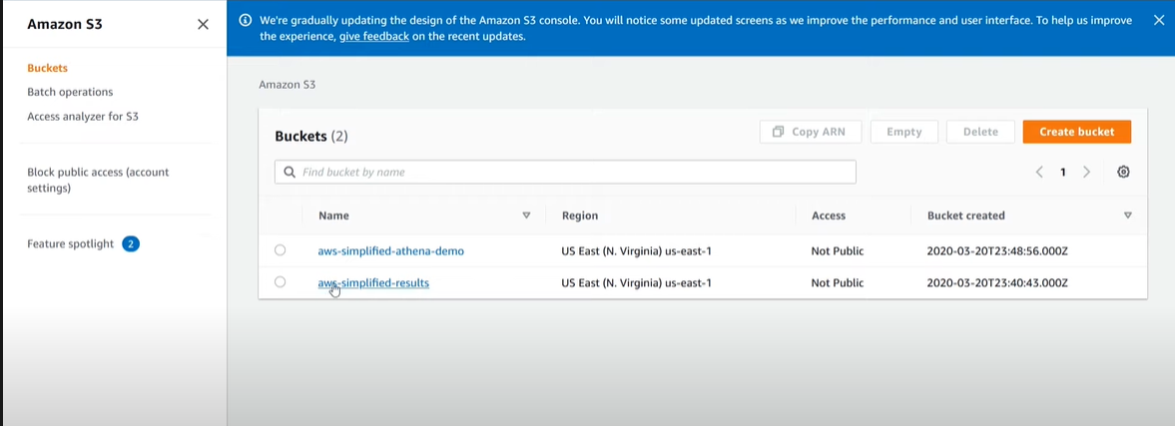

1. After clicking onto the bucket add files to it.

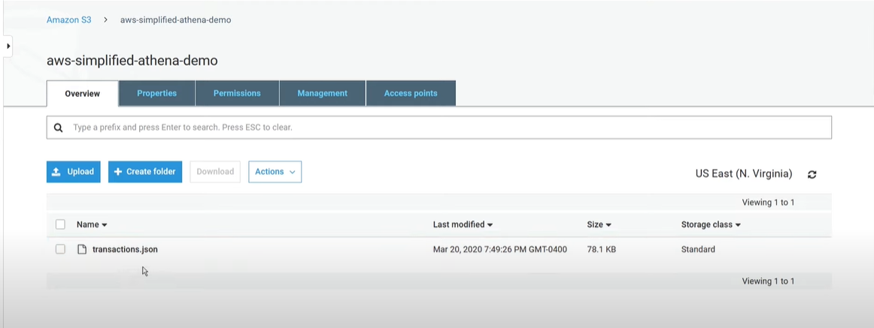

1. Now go to Amazon athena.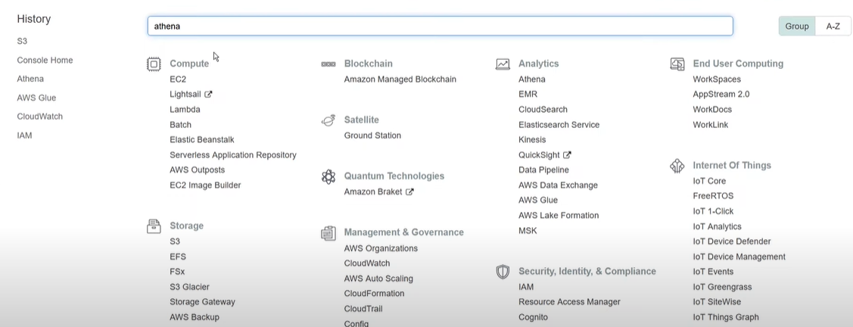
2. Select AwsDataCatalog in the left side which is present in the data source tab.

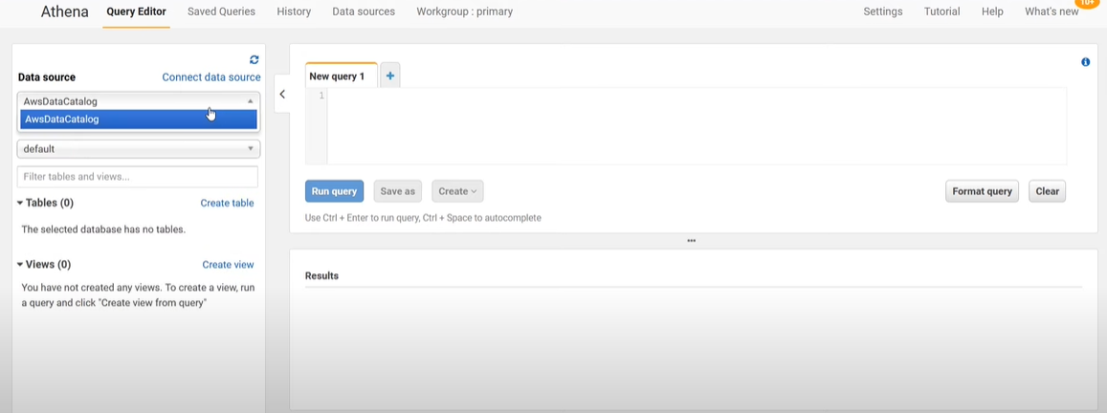

1. After that go to settings and specify an output path.

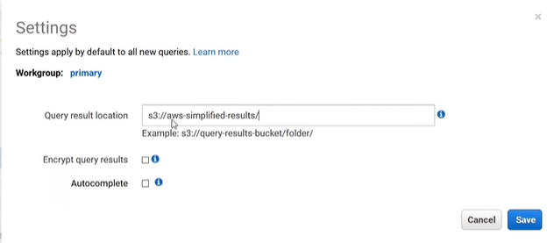

1. Click on connect data source.

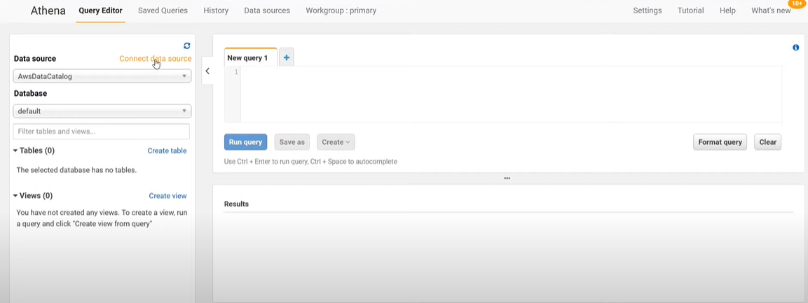

1. After clicking choose a query in amazon s3 and Aws glue data catalog.

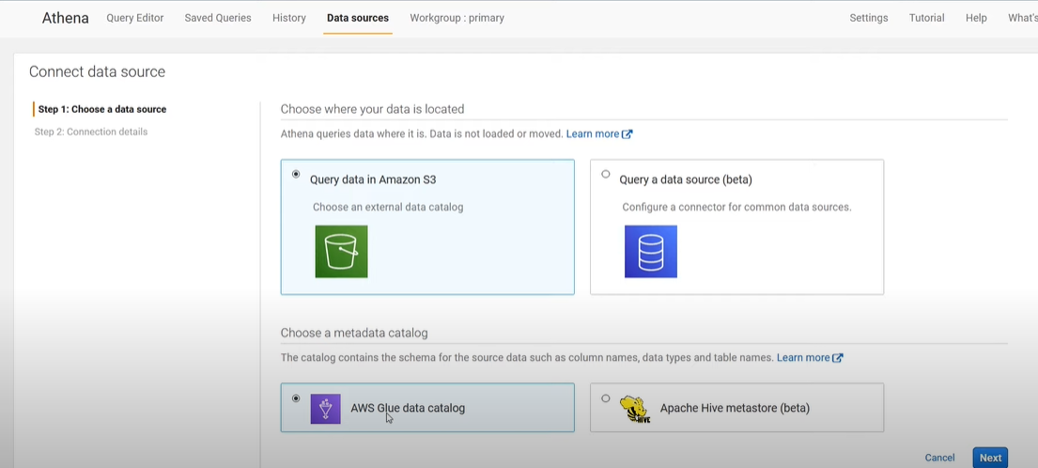

1. Click on next and select setup a crawler in AWS glue to retrieve schema information automatically.

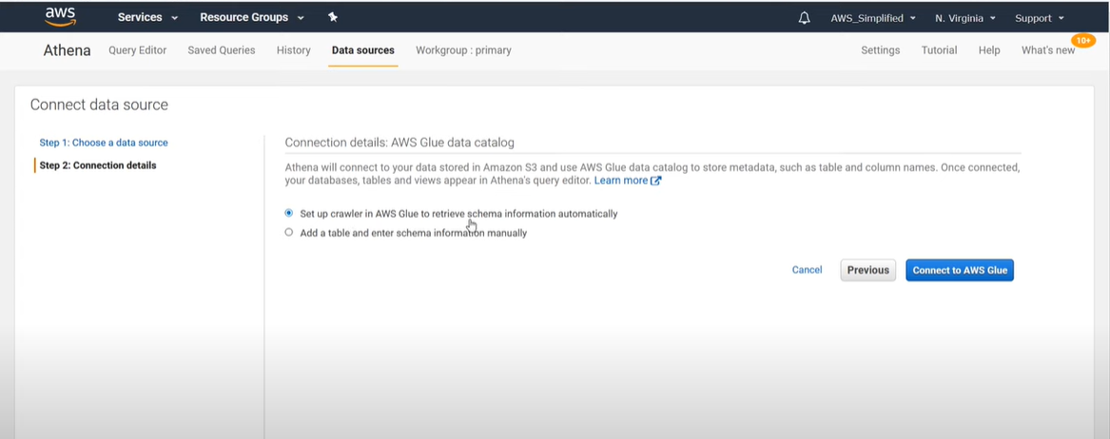

1. After selecting that it will redirect to a new page and add crawler and follow below steps to add a new crawler after setting up click on finish.

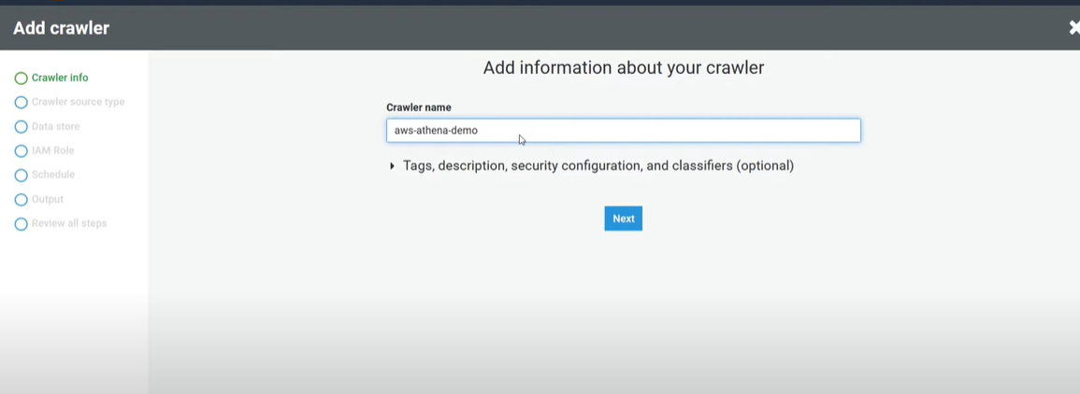

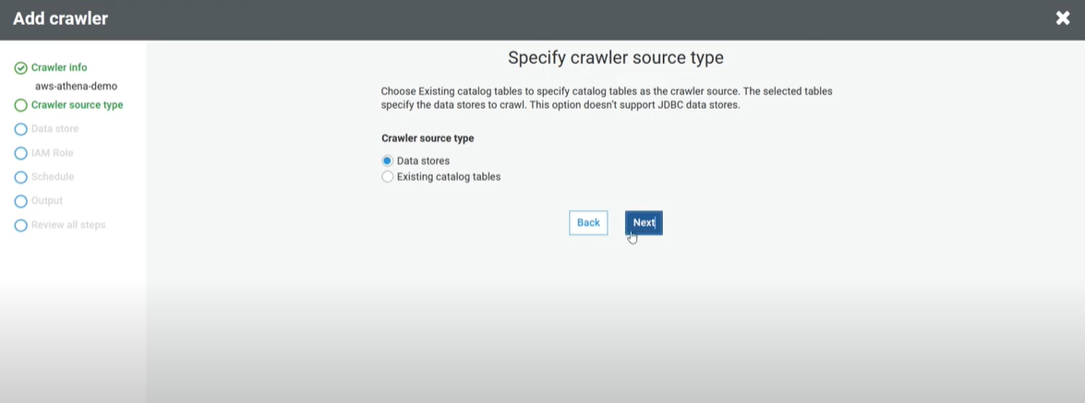

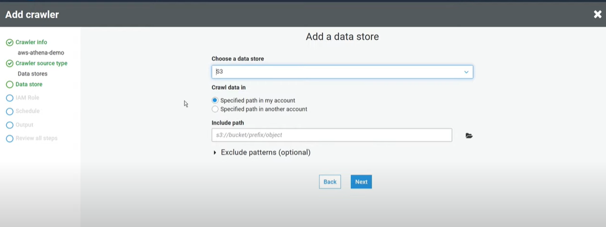

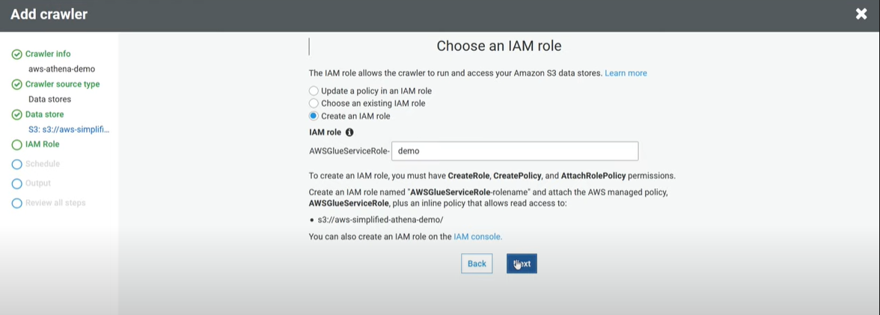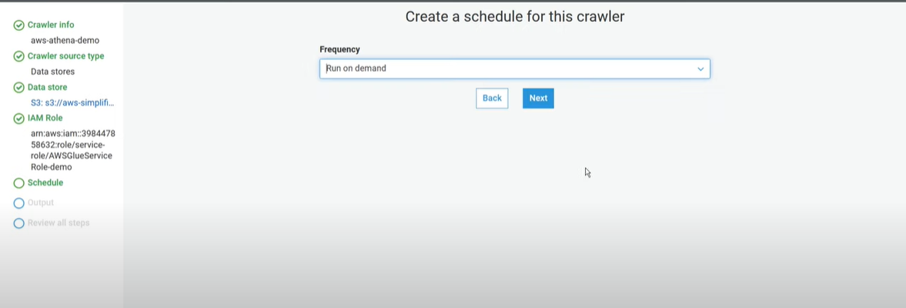

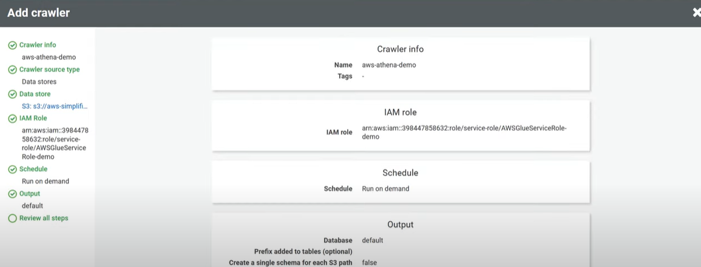

1. Crawler is successfully created and now click on the crawler and click run crawler.

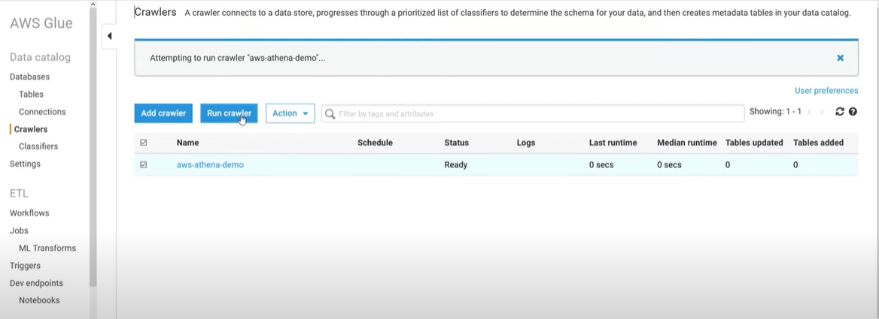

1. After running the crawler go back to athena you will see a table created on table column select that and click on preview table.

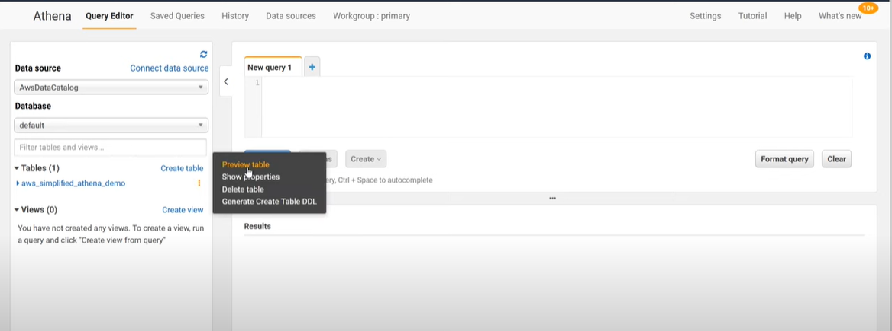

1. Now the query can be executed.

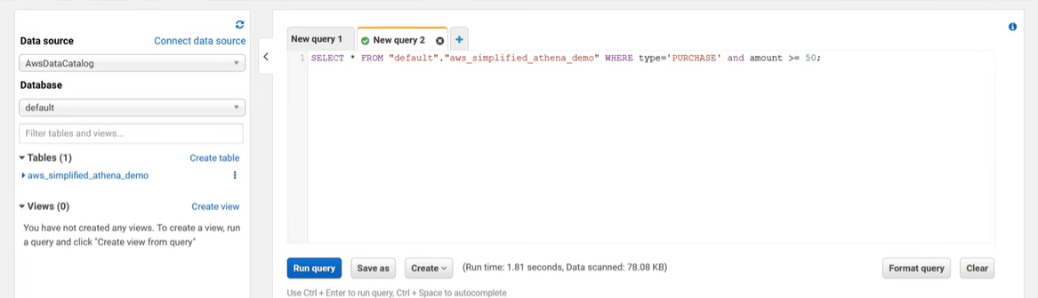

***Result :***

Querying Data in S3 with Amazon Athena is done and output is verified.